

**Carrier 5.0HP A5CKY 50ER/A5LCY 50FR**

**Rs. 135,000/-**

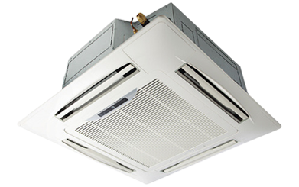

**Product Features**

* super quiet mode
* comfortalble sleep mode
* evaporator self-cleaning
* Inner brass screw high efficiency exchange heat
* auto mode

**Specification**

**Type** Ceiling Cassette AC

**Cooling (Btu/h)** 43000

**Voltage (V)** 220-240

**Power Input (W)** 6200

**EER (Btu/W-h-W/W)** 5.7-2.8